## Alderaan: Design Document

Angelo Nicolson, Joshua Sim, Kale Twist, Johnny Chadwick-Watt

24010970, 22004867, 23009939, 23003660

## Introduction

Alderaan is a sci-fi FPS game which takes place aboard the Imperial Starship Alderaan. The ship has suffered from a swift, and deadly plague, turning the crew into mindless zombies. Everyone has been infected, except the player. The player must navigate through the maze of corridors to reach a life pod to escape, evading or killing any zombies encountered.

Inspired by classic FPS games such as Wolfenstein or Doom, Alderaan combines fast paced combat, and immersive 2.5D visuals.

## Features

* Dynamic 2.5D Environment: Walls, enemies and items are all rendered with perspective scaling, creating a very convincing illusion of a 3D environment.
* Multiple Weapons: Three weapons (Laser Pistol, Laser Rifle, Laser Shotgun) each with unique stats.
* Health and Weapon Pickups: consumable items which restore health or grant new weapons.
* Enemy AI: Enemies which transition between idle, alerted and chasing states. The enemies have directional and walking animations.
* Inventory Management: Limited ammo availability for rifle and shotgun to encourage careful planning, the pistol delivers less damage, but has unlimited ammo.
* Game States: Provides a Main Menu, multiple levels of game play, a how to play screen, credits and game over screens.

## 

## Design Decisions

### Gameplay Mechanics

**Raycasting**

We took a raycasting approach to create a pseudo 3D environment. The engine uses a 60 degree field of view and dynamically renders walls, sprites and a minimap.

**Controls**

The standard WASD controls are used for player movement. With mouse-based camera rotation for aiming and a mouse press to fire weapons. ‘Q’ and ‘E’ keys are used to switch weapons to provide a simple and intuitive way to manage player inventory.

**Combat**

Players start with a Laser Pistol, the standard firearm for all crew members aboard Alderaan. Throughout the journey to the Life Pod, the player may pick up Laser Shotguns or Rifles. Each weapon has distinct damage, fire rate and ammo mechanics. Any zombies the player encounters will chase the player and attempt to attack. Fortunately, the zombies do not have the motor skills to operate their weapons, so the player only needs to be concerned about Melee attacks.

We chose hitscan for our weapon mechanics due to its simplicity and performance efficiency, ensuring the game runs efficiently alongside our multiple enemies and real time raycasting

### 

### Visual and Audio Design

**Environment**

The games 2.5D environment is rendered using a ray casting engine which creates a convincing 3d effect with perspective scaled walls enemies and items. The levels are designed to reflect an imperial starship, with each level representing a distinct section of the ship. The further away the walls are from view, the darker they appear.

**Enemy Visuals**

Enemies, modeled from stormtrooper crew members, have turned into zombies. We use a sprite sheet with animations for idle, alerted, chasing, attacking and dead states which are all managed in our 'Enemy' class. Similar to the environment, the further away the enemies are, the darker they appear.

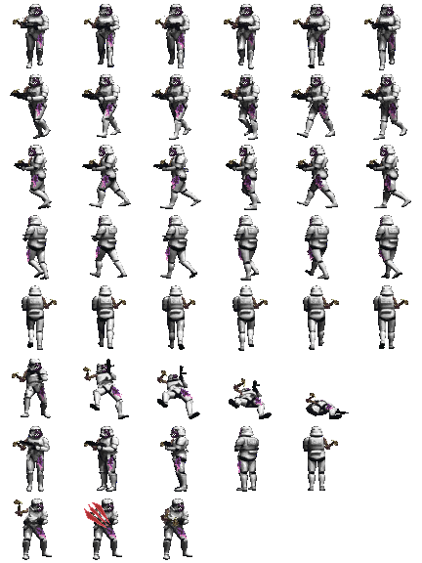 - StormZombieSpriteSheet.png.

A red-tinted hit sprite is also used to provide visual feedback for damage.

A black-tinted hit sprite is also used to provide shading.

**Screens**

The main menu screen, how-to-play, settings, and credits screens use a background image showing Alderaan's exterior. While the Game Over Screen features the same ship in a destroyed state. The Victory Screen features the ship with small animated parts. There are also simple text on black screens in between levels to indicate the level number.

**Audio Design**

Each weapon has a distinct firing sound to reflect the different guns.

We have applied appropriate sounds to demonstrate events such as the player being injured, a zombie dying, a weapon reloading or a item being picked up. Other audio effects, such as win condition sounds (such as the door opening) are being used to create a subtle yet important audio effect and create a more convincing environment.

### User Interface

**HUD**

Our simple HUD displays a health bar, the equipped weapons name and ammo count.

**Menu System**

A main menu with options for starting the game, How to Play instructions, settings and credits to provide users a polished and intuitive entry point. The main menu can be accessed at any time while playing the game by pressing Escape. The game will pause itself, and the player can resume the game again with the Resume Game button.

### 

### Team Contributions

**Angelo Nicolson**

Organized team meetings and collaborated with Joshua on the initial game planning. Responsible for managing version control, resolving merge conflicts that arose and reviewed pull requests ensuring smooth and effective team collaboration. Refactored code for best practices, optimizing methods and removing redundant code, keeping our code clean. Developed the Enemy and EnemyAI classes, implementing the initial zombie behaviours and animations. Created the minimap.

**Joshua Sim**

Responsible for Gameplay Design and the Artist. Worked alongside Angelo in the initial planning stages of the game. Created the original Design Documentation which served as the blueprint for our project. Provided the Visual and Audio assets. Contributed significantly to the code, such as providing the initial raycasting code, which formed our game's rendering foundation and created the levels. Added sci-fi textures to the walls. Added and animated the victory screen. Joshua also created the Game Trailer video for the project.

**Kale Twist**Implemented: enemy death mechanics, enemy shading mechanics, enemy hit mechanics, muzzle flash mechanics, graphics settings, between levels scenes, the “pause” and “resume” ability, enemy striking animations and improved settings and how to play screens as well as the mini map experience.

**Johnny Chadwick-Watt**

Responsible for managing player controls, including player movement and mouse aiming, and the players health system. Created the Weapon class, and health/weapon pickup mechanics (the HealthItem and WeaponItem class). Implemented the weapon sprites provided by Joshua for both equipped weapons and pickup items. Designed the HUD (health bar, weapon info) and all menu screens. Author of the project's documentation (this document).

## Screenshots

**Main Screen  
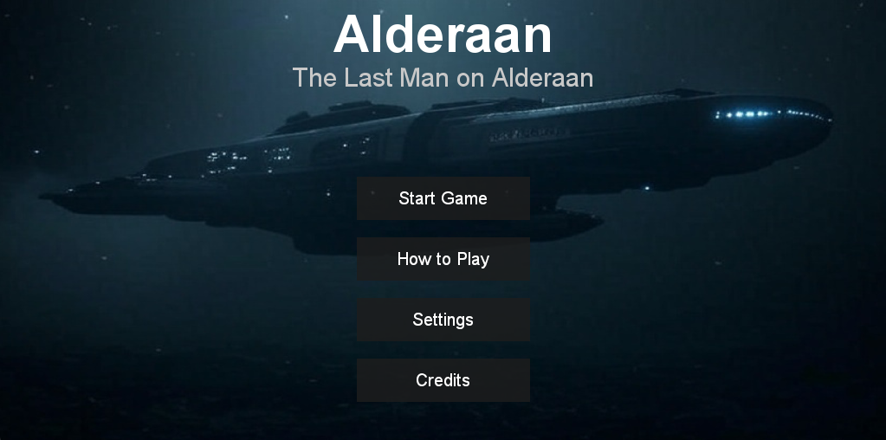**

**How to play  
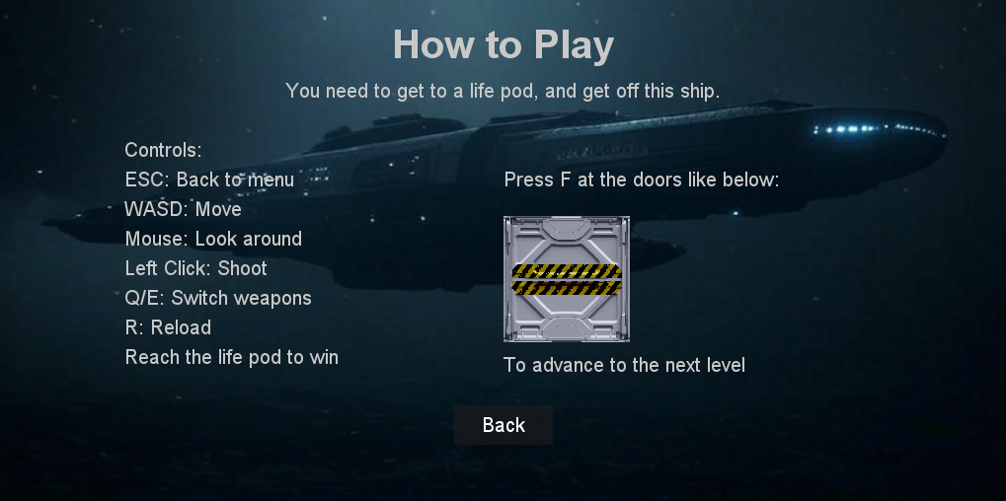**

**Settings  
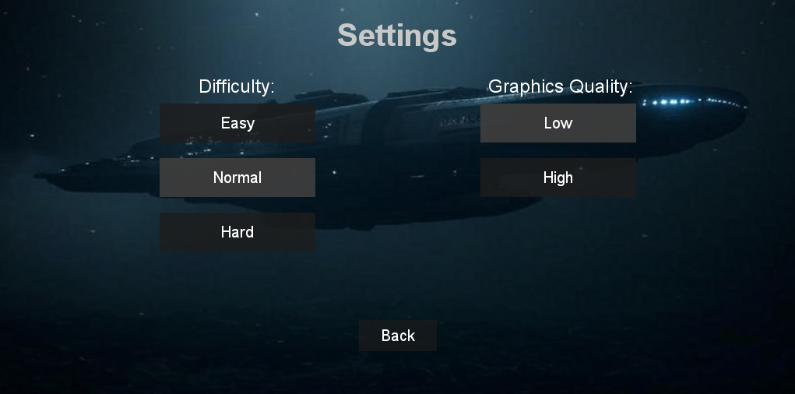  
Credits  
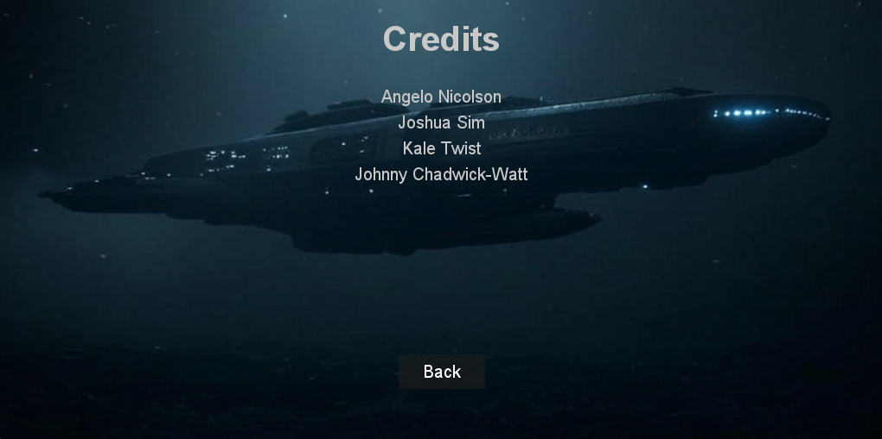  
  
Gameplay / Enemies / Pickups**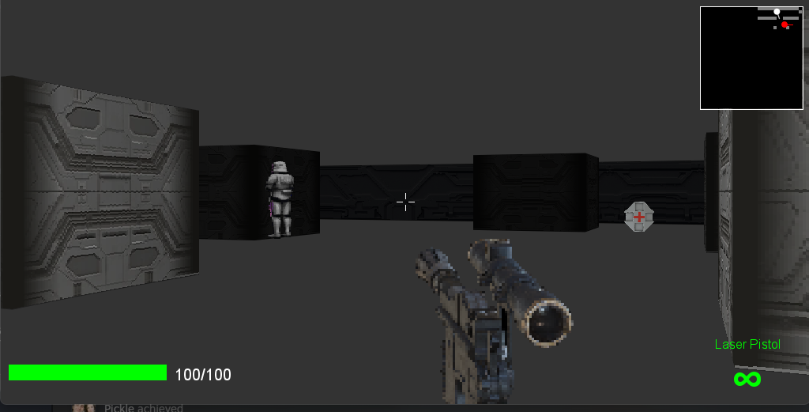

**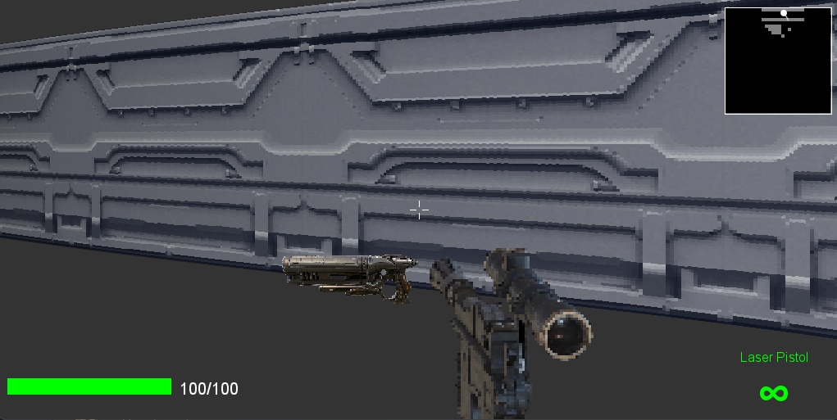  
Game Pause Menu  
